EXPENSE ANALYZER
@CREATIVITY THINK (9483175986/7019689991)

ABSTRACT:
The Expense Analyzer is a web-based platform designed to help individuals, families, and students track their financial activities and understand spending patterns. The system allows users to log expenses, categorize them, analyze financial dashboards, and export reports in CSV or PDF formats. Administrators manage categories, monitor family accounts, and generate usage analytics. Built using Django and Django Rest Framework for backend operations and React with Chart.js for interactive data visualization, the platform ensures secure data handling and intuitive financial monitoring. The project aims to promote better financial decision-making through structured tracking and data-driven insights..

INTRODUCTION OF THE PROJECT:
Managing expenses effectively is essential for maintaining healthy financial habits, yet many individuals struggle with unorganized or manual tracking methods. The Expense Analyzer provides a centralized platform where users can record expenses, visualize spending behavior, and export financial summaries. It supports real-time dashboards, category-based tracking, and detailed analytics. Administrators handle category management, usage monitoring, and analytics generation. Using Django for backend processes and React with Chart.js for dynamic visualizations, the system enables accurate, efficient, and user-friendly financial supervision across personal and shared accounts..

PROJECT OBJECTIVES:

• To provide a structured platform for users to record and categorize expenses
• To offer visual dashboards for analyzing spending patterns
• To enable exporting of data in CSV and PDF formats
• To assist families and groups in managing shared expenses
• To allow admins to manage categories and analyze usage trends
• To support informed financial decision-making

PROBLEM OF THE STATEMENT:
Individuals often face difficulty managing finances due to scattered information, lack of categorization, and absence of visual insights. Manual tracking can lead to errors, missing entries, and poor financial understanding. Families handling shared expenses struggle to coordinate spending transparently. Without analytics or structured reports, users cannot monitor trends or make informed decisions. The Expense Analyzer addresses these challenges by offering automated expense logging, categorization, dashboard analytics, and exportable reports. Admins can track usage patterns and manage categories, ensuring an organized and efficient financial monitoring experience..

MOTIVATION OF THE PROJECT:
• Encourage better financial responsibility and awareness
• Replace manual tracking with automated digital workflows
• Provide visual insights for improved decision-making
• Support shared expense tracking for families
• Enable structured and exportable financial documentation

BLOCK DAIGRAM OF PROJECT:

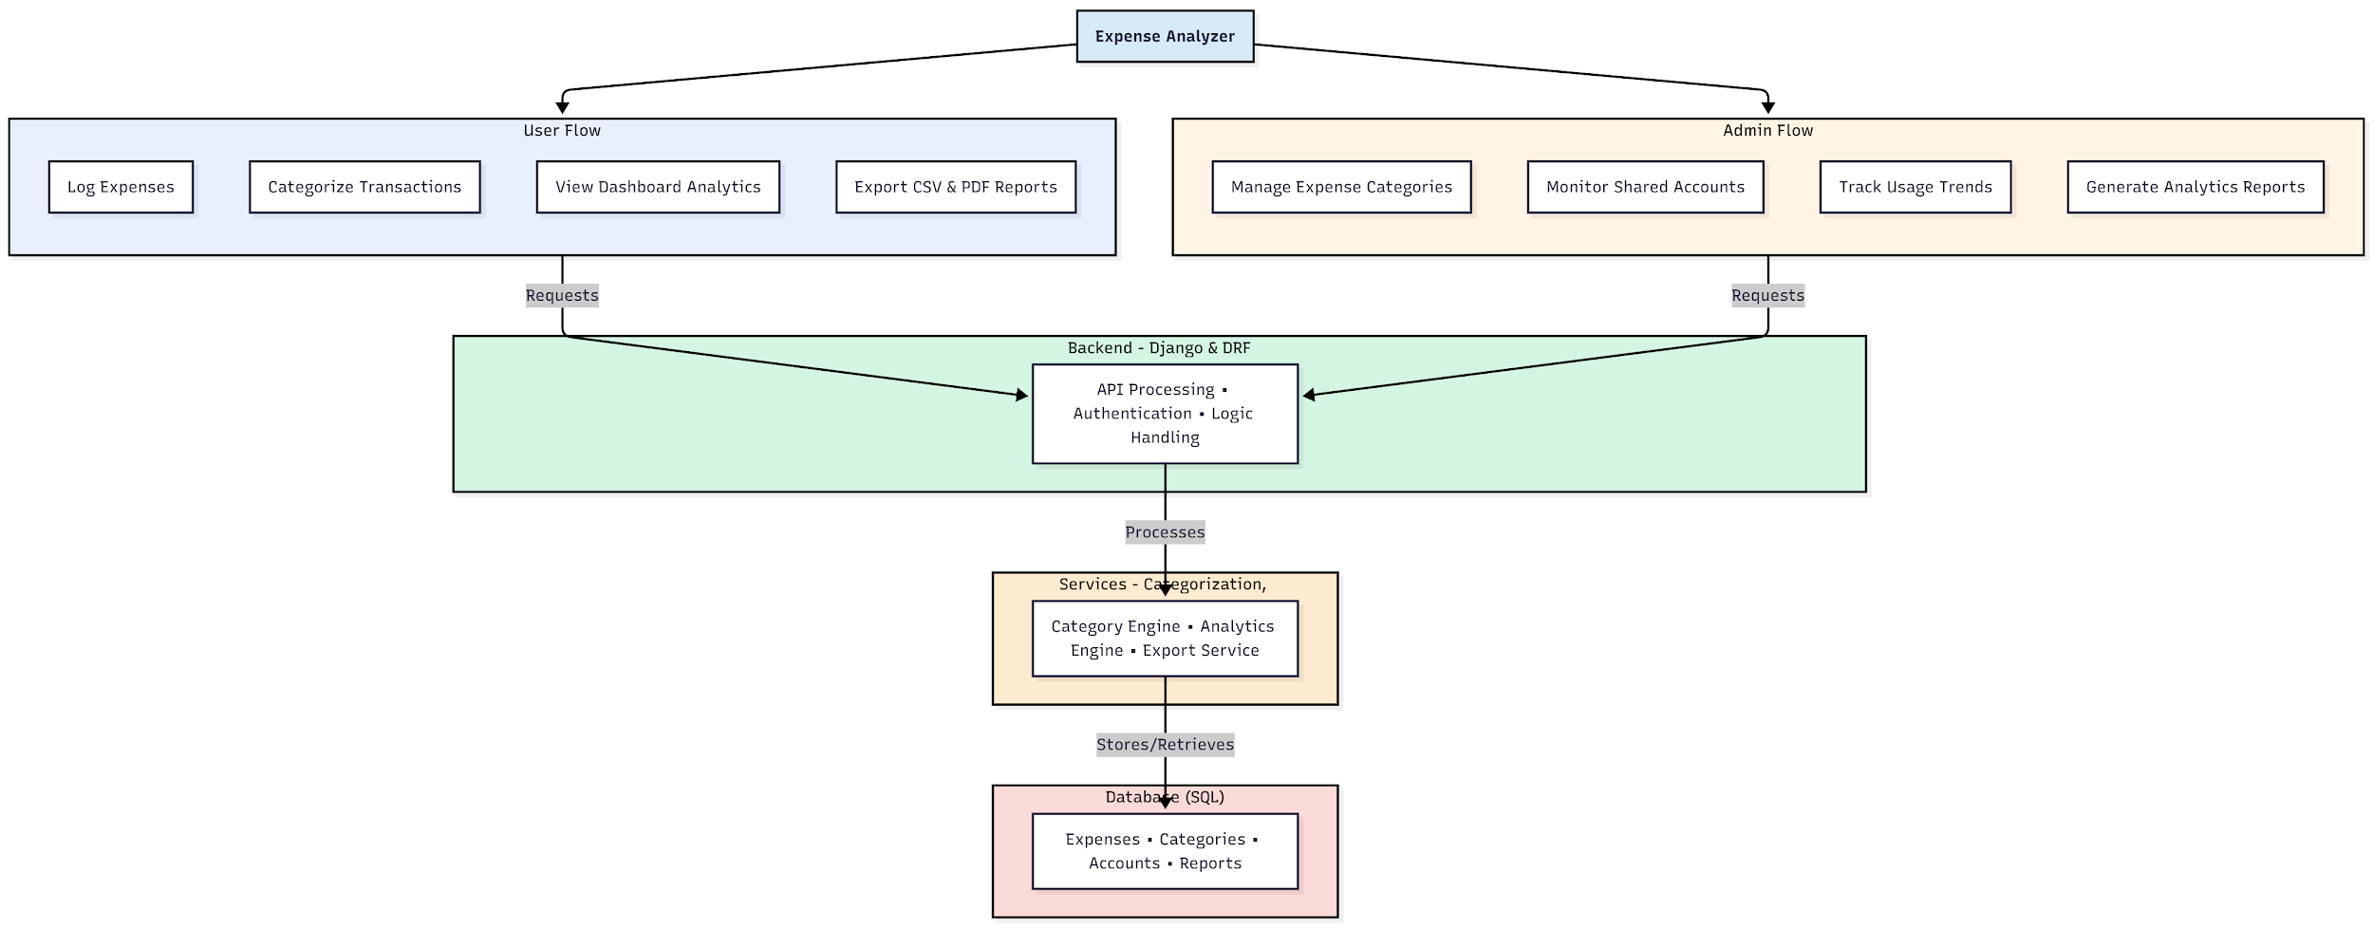

WORKING OF THE PROJECT:
The Expense Analyzer enables users to log their expenses, categorize them, and view interactive dashboards that display spending trends. Users can export their financial summary in both CSV and PDF formats for personal use or reporting purposes. The backend processes all requests, handles authentication, and manages business logic, while services handle analytics generation, category mapping, and file export. Administrators manage expense categories, monitor shared accounts, analyze usage trends, and generate system analytics. The system operates as a unified platform to provide structured, data-driven financial management for individuals and groups..

SOFTWARE REQUIREMENT:
- Backend:
  - Python 3.x
  - Django
  - Django REST Framework
  - SQLite/PostgreSQL
- Frontend:
  - Node.js and npm
  - React.js
  - Axios
- Development Tools:
  - Visual Studio Code
  - Postman (for testing APIs)
  - Git/GitHub (for version control)
- Server/Deployment (Optional):
  - Gunicorn, Nginx, or Heroku/AWS for hosting

ADVANTAGES OF THE PROJECT:

• Simplifies financial tracking and categorization
• Provides visual breakdowns for spending awareness
• Supports CSV and PDF export for documentation
• Enables shared account tracking for families
• Helps identify expense trends and overspending
• Enhances organization with structured data storage
• Reduces manual bookkeeping errors
• Supports real-time analytics for informed decisions

APPLICATIONS OF THE PROJECT:
• Personal financial management
• Family shared expense tracking
• Student budget monitoring
• Household budgeting and planning
• Small-scale financial reporting
• Monthly expense documentation for tax purposes
• Expense analysis for personal loans and planning
• Financial awareness programs and institutions

REFERENCES:

- Django REST Framework Documentation — Django Software Foundation. Django Documentation. Available: https://docs.djangoproject.com/
- Django REST Framework. DRF Documentation. Available: https://www.django-rest-framework.org/
- React. React Official Documentation. Available: https://reactjs.org/docs/getting-started.html
- Redux. Redux Documentation. Available: https://redux.js.org/introduction/getting-started
- PostgreSQL Global Development Group. PostgreSQL Documentation. Available: https://www.postgresql.org/docs/
- MySQL. MySQL Reference Manual. Available: https://dev.mysql.com/doc/
- Git. Git Documentation. Available: https://git-scm.com/doc
- Node.js. Node.js Documentation. Available: https://nodejs.org/en/docs/
- Axios. Axios Documentation. Available: https://axios-http.com/docs/intro
- Socket.io Documentation – https://socket.io/docs/

